Connecting to managed AWS services

A. Network troubleshooting scenarios
- My EC2 response times are very slow
- I can’t access my EC2 through Secure Shell (SSH)
- My EC2 database isn’t applying any patches.

B. Amazon VPC flow logs

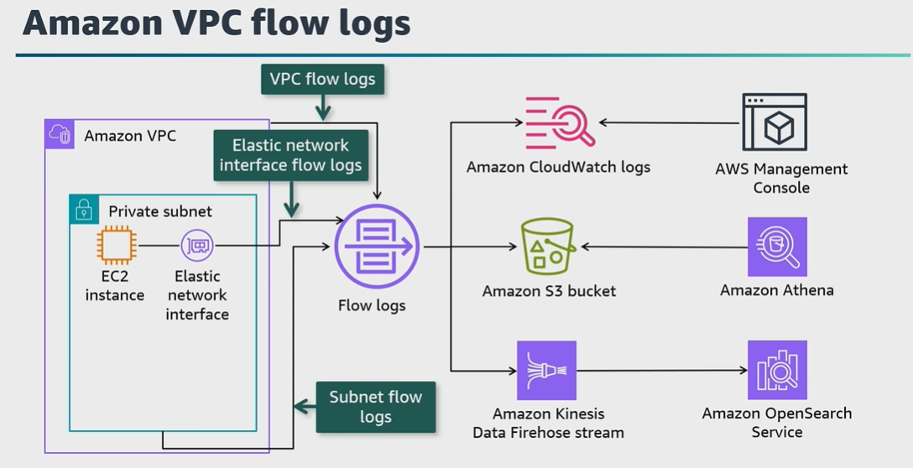

C. Flow log IAM access policy
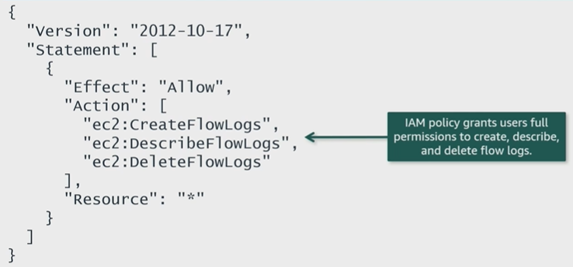

D. More VPC troubleshooting tools

Reachability Analyzer: Test connectivity between a surce and destination resources in a VPC

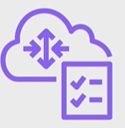
Network Access Analyzer: Identify unintended network access to user’s resources on AWS


Traffic Mirroring: Make a copy of network traffic to send to security and monitoring appliances

E. Conclusions
- Use VPC Flow logs to capture information about the network traffic in your VPC
- Flow log records consist of all flows within a an aggregation interval
- Use Reachability Analyzer to test whether two resources in a VPC have connectivity.
- Use Network Access Analyzer to identify unintended network access to resources in AWS account
- Use Traffic Monitoring to make a copy of user’s network traffic to send to security and monitoring appliances

